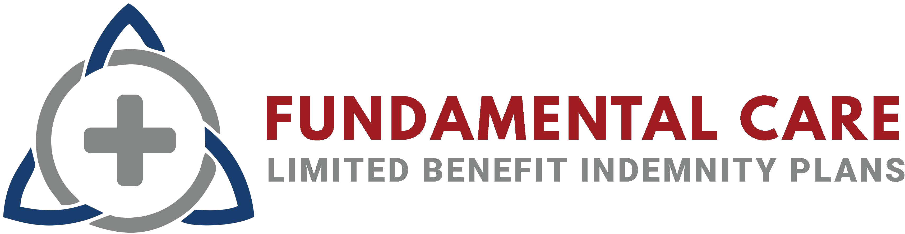Enhanced Plan Benefits

# Physician and Hospital PPO Network - $10 Office Visit Prepay

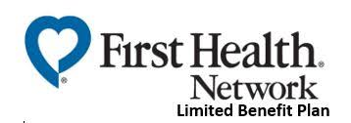First Health is a national PPO network, with wide-ranging access in both urban and rural areas. Although employees are free to use any provider they choose, when they access services covered under the GLI plan, from a provider who participates in the First Health preferred provider network, they may be eligible for discounts off the total that is due for the service. This could reduce the amount owed after the full insurance benefit has been paid. NOTE: Insureds pay **a $10 Office Visit Prepay** at in-network physicians and urgent care centers.

# Provider Look Up:

800.226.5116

**For the GLI plan** [www.firsthealthlbp.com/fhlbpfi](http://www.firsthealthlbp.com/fhlbpfi)

# Pharmacy Network and Prescription Discounts

The NBFSA Pharmacy Benefit Administration (PBA) benefits included with this plan members access to savings on a wide variety of prescription drugs. The NBFSA nationwide pharmacy network includes [all major chains, retailers,](http://www.firsthealthlbp.com/) grocers, and independents. Employees can use the information on their ID cards to get prescriptions filled at any participating pharmacy.

# Pharmacy Help Desk:

Call:1-877-539-3940 or visit the link listed on your ID Card

MeMD provides 24/7/365 access to board certified doctors and pediatricians.

* 24/7 access to consult with a licensed physician by phone or video
* $0 consult fee and unlimited visits for all urgent and primary care visits
* Physicians can write prescriptions when applicable
* Link: memd.me/telemed

#### Phone Number: 1-855-636-3669

# Employee Assistance Plan and Counseling

The comprehensive Employee Assistance Plan (EAP) is provided by CuraLinc. Their SupportLinc program is staffed by professional, licensed counselors available to members by phone 24/7/365 at no cost. Provides up to three (3) face-to-face counseling sessions per presenting issue for a wide array of personal and work-related concerns at no cost.

1-888-881-5462

[www.supportlinc.com](http://www.supportlinc.com/)

# Username: coterie

**Health Services Hub**

Access all of your Enhanced Benefits listed above through a single member portal! [www.healthserviceshub.com](http://www.healthserviceshub.com/)

Login with your Member ID

Passcode: benefits18

**Administrative Concepts Inc.**

For eligibility, benefit, and claims questions, call the program administrator, Administrative Concepts, Inc. at: **1-800-508-9238**

*Fundamental Care contracts with third-parties to offer these noninsurance services. The fees for these products are combined with Beazley insurance premiums. These third-party services are not offered or underwritten by Beazley.*